Calculation of Walking Catchments

**Gabriel Thompson de Wit – 3rd April 2016**

**Technique.** An image is overlaid on a Google Maps layer with black pixels representing nodes (spacing the nodes closer together gives better resolution when calculating metric reach, but requires more data processing work later; I used 603 to cover the Auckland CBD). This image is read into MATLAB, and the nodes are plotted with labels. The adjacency matrix of the network is then constructed by hand in a spreadsheet (I’m experimenting with reading the adjacency structure directly from an image using image processing methods). After data cleaning, the shortest path matrix for the network is calculated using Dijkstra’s algorithm, and walking catchments are then plotted for a given node and catchment threshold.

*Figure 1 Walking catchments for: Jellicoe St (top left), Union St (bottom left), O’Connell St (top right), Wakefield/Symonds St (bottom right); nodes coloured red and walking catchments coloured green.*

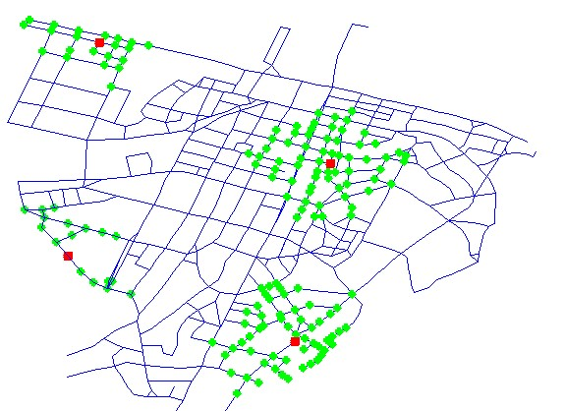

**Shortcomings and directions for future work.** This technique gives a strong sense of the relative connectivity of different locations in the Auckland CBD, but is ultimately a first order model, and has several features which could be developed further.

* Calculations of the numeric-valued **metric reach** (Peponis et al, 2008 - *The connectivity of streets: reach and directional distance*) – this would be inappropriate here as no buffer was used, meaning calculations of metric reach would be susceptible to edge effects (Gil, 2015 - *Examining 'Edge Effects'*) e.g. Union Street extends into Freeman Bay through Wellington Street which is not captured here.
* Refinements of the network model: using the actual footpath network as opposed to street centrelines, which has been shown to have an effect on estimates of connectivity (Ellis et al, 2016 - *Connectivity and Physical Activity: …*), as well as incorporating information about gradient (Finnis & Walton, 2007 - *Field Observations of … Pedestrian Speeds)* and information on signal phasing at pedestrian crossings. These would all manifest as spatially-dependent impedance functions.
* Incorporation of various types of data into the analysis, such as information on footpath width, which has been shown to affect pedestrian activity (Ozbil et al, 2015 – *Modeling Walkability: …*), GIS data (this would be awkward without employing GIS technology), traffic and pedestrian count data, economic data (e.g. for analysis of access to jobs/commerce/customers).
* Accounting for transit; bus stops/train stations can be incorporated as nodes with a time-varying impedance function to represent waiting times. This would make true sense only with a model for the wider Auckland area. It is also important to account for cycle networks, but the lines are often blurred between pedestrian and cycling networks so this would not be completely straightforward.
* Examples of applications: transport network planning e.g. use as a tool during network design, evaluation of changes/perturbations to network structure e.g. footpath closures, prediction of pedestrian activity e.g. estimating pedestrian activity on streets where Heart of the City do not record pedestrian count data (which can then be applied to examining the potential for economic activity in various places).